
Development Request
Aria Systems
Enhancement # 500452

Name: Care Label & Hang Tag Designer
Status: Not Approved

Product: | Aria27
Module: | Manufacturing/Importing
Customer name: | Liberty Apparel
Installed Modules: | Most Aria modules: BASE, Manufacturing, Raw Materials….
Parameters setting:

General

Care labels and Hangtags get attached to garments to show specific information about the style (such as washing instructions, fabric contents…). In the past Labels used to be text based but now because of customer needs and legal requirements labels sometimes need to show graphical signs and print text with Special fonts. Therefore we have to recreate our text based Label Printing program to be graphical based. The general logic of this program is identical to the one previously created in FoxPro DOS .

Needs:

- Allow the user to print text with any Windows Font:
The system should allow the user to change the font of any text that is printed on the label.

- Allow the user to select graphics to printed on the label:
Specific small graphics sometimes to be printed on the labels, those graphics may be a logo or specific care instructions commonly found on garment labels.

- Need a simple process to create labels:
The process to create labels needs to be extremely simple and user friendly.

- Need the program to work for both imported and domestic styles:
The program to print labels needs to work based on either cutting ticket information or style purchase orders.

Required Entities:

- Care Label & Hang Tag Designer: Add New program in the transaction menu called “Care Label & Hang Tag Designer” to allow the user design/modify and save labels.
- Hang Tag & care label program: Modify the hang tag & care label program in the output menu to display the standard option grid to allow the user to print/preview care label & hang tag by using the label designed from the care label & hang tag designer program.

Care Label & Hang Tag Designer:

Care Label & Hang Tag Designer pages:

- Choose Label Dimensions Page.
- Define Layout Page.
- Finish Page.

Page 1: Choose Label Dimensions

Features:
- The screen will allow the user to use label definition in “English” or in “Metric”.
- The screen will allow the user to use the standard label dimensions.
- The screen will allow the user to control add/delete/edit custom label dimensions.

User interface:
- Please refer to the sample layout below:
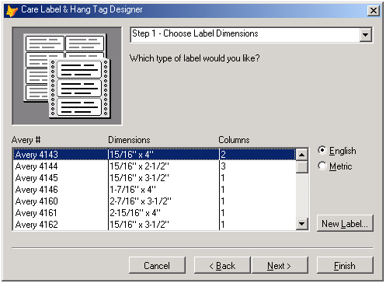

Screen functionalities and Business Rules:
Object | Rule
Step popup | Display the current step and list all steps to give the user ability to jump to another step.
Dimension list | List all standard label dimensions and user defined label dimensions depend on English or Metric system are selected.  The user must select one of these dimensions or create new label dimension by using “New Label…” button.
English option button | To display only English label dimensions
Metric option button | To display only Metric label dimensions
New Label button | To allow the user to control the user defined label dimensions
Cancel button | To cancel designing label end exit from program
Back button | To go step back (disabled for step 1)
Next button | To go to the next step
Finish button | To done the label design
- The standard and user defined label dimensions will save in the LABELDIM.DBF file.
- The LABELDIM.DBF file structure is:
Field Name | Type | Width | Description
CLblName | Character | 30 | Label Name
CLblDim | Character | 40 | Label dimension (i.e. 2.5 cm x 1.5 cm)
CLblUom | Character | 1 | Label Unit of Measurement (E=English/M=Metric)
CLblType | Character | 1 | Label Type (S=Standard/U=User defined)
NLblHeight | Numeric | 9,3 | Label Height
NLblLftMrg | Numeric | 9,3 | Label Left Margin
NLblNmbAcr | Numeric | 2,0 | Number of labels across
NLblSpcBtw | Numeric | 9,3 | Space between labels
NLblTopMrg | Numeric | 9,3 | Label Top Margin
NLblWidth | Numeric | 9,3 | Label width

Custom Label screen: this screen will displayed when press in the new label button in the step 1 screen.
Features:
- The screen will allow Add/Delete/Edit user defined labels.
User interface:
- Please refer to the sample layout below:
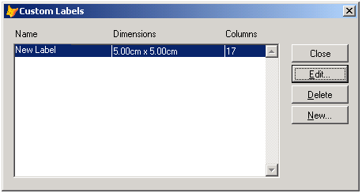
Screen functionalities and Business Rules:
Object | Rule
Custom Labels list | List all user defined labels dimension saved before in the system
Close button | To return back to the step 1 screen
Edit … | To edit dimensions of the selected label
Delete | To delete the selected label dimensions
New … | To create new label dimensions
Custom Label screen: this screen will displayed when press in the edit or new button in the custom label screen.
Features:
- The screen will allow the user to use English or Metric systems.
- The screen will allow update the label dimensions.
User interface:
- Please refer to the sample layout below:
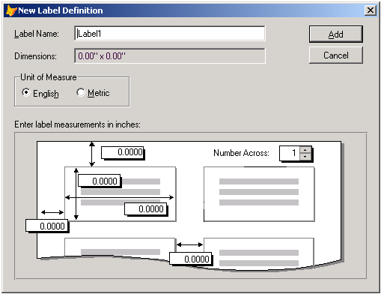

Screen functionalities and Business Rules:
Object | Rule
Label Name | Display the label name (editable only if create new label)
Dimensions | Display the dimensions of the label (not editable)
Unit of Measure | To select the measurement system to use (English/Metric)
Top margin | Define the top margin
Left margin | Define the left margin
Label Height | Define the label Height
Label Width | Define the label Width
Spacing between the labels | Define the spacing between the labels
Number Across | Define the number of columns for labels
Page 2: Define Layout

Features:
- Allow the user to select on of the available fields to add into the label.
- Allow the user to add text field or picture to the label.
- Allow the user to define the font name/size/style for each object in the label contents.

User interface:
- Please refer to the sample layout below:
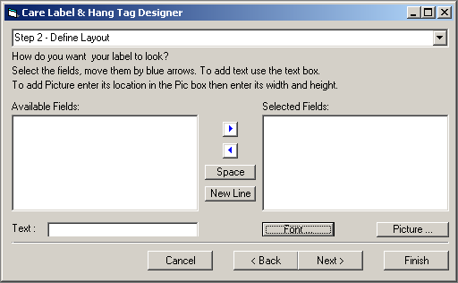
Screen functionalities and Business Rules:
Object | Rule
Available Fields list | Display the available fields for select to add in the label
Selected Fields list | Display the contents of the label
Right Arrow button | Add the selected Field in the available fields list to the label in selected line of the selected fields list  If the text file contained a text then add this text to the label in selected line of the selected fields list  If the picture location not empty then add this picture to the label in selected line of the selected fields list
Left Arrow button | Remove the last object from the current line in the label
Space button | Add one space to the current line in the label
New Line button | Add new line to the label
Text | To Add text to the label fill this text box and press into the right arrow button
Picture button | To display the picture dialog box to select picture to add to the current line in the label
Font | To display the font dialog box to determine the font name/size/style
Picture dialog box

User interface:
- Please refer to the sample layout below:
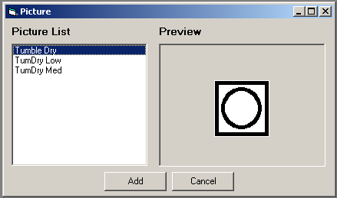
The user will select picture from the picture list and it will preview in the right area then press in the Add button to add this picture in the label.

Page 3: Finish
Features:
- Allow the user to save label for later use.
- Allow the user to save label and modify it.
- Allow the user to save and print labels.
- Allow the user to preview the label.
User interface:
- Please refer to the sample layout below:
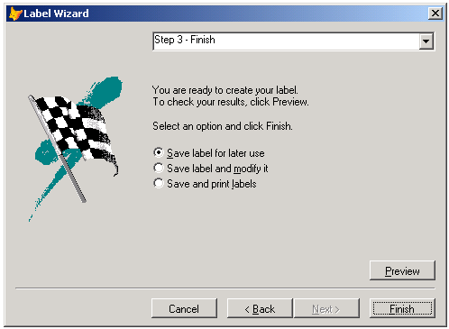
Screen functionalities and Business Rules:
Object | Rule
Save label for later use | Display a dialog box to enter the label name and save the label for later use by hang tag & care label menu item at the output menu
Save label and modify it | Display a dialog box to enter the label name and open the label to modify it
Save and print labels | Display a dialog box to enter the label name and open the option grid of hang tag & care label to print label
Preview | To preview the label before save it.
Hang Tag & Care Label program:

Features:
- Allow the user all features of our standard option grid with the same option in the old program.
Option Grid :
Header | Type | Description
Select | Popup | To Select one from the following to filter in:  Entered (for entered date)  Complete (for complete date)  Ticket # (for cutting ticket number)  Vendor (for vendor code)
Status | Popup | To select the cutting ticket status from the following:  Open/Hold/Actual/All
Percentage | Numeric | To print percentage from the cutting ticket quantity
Select size | Popup | To select size to print from the following:  All/1/2/3/4/5/6/7/8
Sorted | Popup | To sort labels by size or by color
Entered | Between | To enter the entered date range displayed only in case of select entered in the first option
Complete | Between | To enter the complete date range displayed only in case of select complete in the first option
Ticket # | In Range | To select some cutting tickets to print displayed only in case of select ticket # in the first option
Vendor | Single field value | To enter the vendor code displayed only in case of select vendor in the first option
Label Name | Single field value | To enter the label name that will used to print

